


GAS LEAKAGE MONITORING AND ALERTING SYSTEM FOR INDUSTRIES
A PROJECT REPORT

Submitted by
RAMKUMAR T D (912219106016)
PRASANNA R M (912219106013)
PRIYANKA P (912219106015)
SWETHA A (912219106020)
NAGARAJAN B (912219106301)

In partial fulfilment for the award of the degree
of
BACHELOR OF ENGINEERING
IN
ELECTRONICS AND COMMUNICATION ENGINEERING
SOLAMALAI COLLEGE OF ENGINEERING,
VEERAPANJAN, MADURAI – 625 020.

ANNA UNIVERSITY::CHENNAI-600 025
DECEMBER 2022

BONAFIDE CERTIFICATE
Certified that this project report “GAS LEAKAGE MONITORING AND ALERTING SYSTEM FOR INDUSTRIES” is the bonofide work of “RAMKUMAR T D (912219106016), PRASANNA R M (912219106013), PRIYANKA P(912219106015), SWETHA A (912219106020), NAGARAJAN B (912219106301)” who carried out the project under my supervision. Certified further that to the best of my knowledge the work reported here in does not from part of any other thesis or dissertation on the basis of which a degree or award was conferred on an earlier occasion on this or any other candidate.

Signature of the Head of Department Signature of SPOC
Mr.B. MAHESH M.E.,(Ph.D) Dr.K. JALALDEEN M.E., Ph.D.
HEAD OF THE DEPARTMENT ASSISTANT PROFESSOR(SG)
Department of ECE Department of ECE
Solamalai College of Engineering, Solamalai College of Engineering,
Madurai-625 020 Madurai-625 020

Signature of Faculty Mentor Signature of Faculty Evaluator
Mr.R. RAMESHKUMAR M. E. Mrs.B. MEENAMBAL M.E.
ASSISTANT PROFESSOR ASSISTANT PROFESSOR
Department of ECE Department of ECE
Solamalai College of Engineering, Solamalai College of Engineering,
Madurai-625 020 Madurai-625 020

Submitted for Naalaiya Thiran (IBM) project on ……………………….

Faculty Mentor Faculty Evaluator

ACKNOWLEDGEMENT
We express our extreme gratefulness to our Chairman Thiru V.S.P.SOLAMALAI PITCHAI, Our Executive Director Thiru S.P.ANAND and Thiru S.P.ARAVIND, Solamalai College of Engineering Madurai for supporting us during the development of the project phase I.
We would also like to express our sincere thanks to our Principal Dr. M. SHANTHI M.E.,Ph.d, Solamalai College of Engineering Madurai for supporting us during the development of the project phase.
We express our sincere thanks to Mr. B. MAHESH M.E.,(Ph.D) Head of the Department, Department of Electronics and Communication Engineering, Solamalai College of Engineering Madurai, for allowing us to use the facilities in the college and supporting us well.
We highly obliged to express our sincere thanks to our project SPOC Dr. K. JALALDEEN M.E,Ph.d Assistant Professor (Senior Grade), Department of Electronics and Communication Engineering, Solamalai College of Engineering Madurai, for his encouragement and valuable guidance rendered to us throughout the project.
Last but not least, we thank our faculty members and non-teaching faculty members and fell a deep sense of gratitude to our Parents and Friends of Solamalai College of Engineering who had been all along encouraging us to endeavour this project.

ABSTRACT

The Internet of things (IoT) is the system of gadgets, vehicles, and home machines that contain hardware, programming, actuators, and network which enables these things to interface, collaborate and trade information. IoT includes broadening Internet network past standard device, for example, work areas, workstations, cell phones and tablets, to any scope of generally stupid or non-web empowered physical device and ordinary articles. Installed with innovation, these gadgets can convey and connect over the Internet, and they can be remotely observed and controlled. The meaning of the Internet of things has advanced because of union of numerous innovations, ongoing examination, AI, ware sensors, and implanted frameworks. A gas spill alludes to a hole of petroleum gas or different vaporous item from a pipeline or other regulation into any territory where the gas ought not be available. Since a little hole may steadily develop a hazardous convergence of gas, spills are perilous. Notwithstanding causing flame and blast dangers, holes can slaughter vegetation, including huge trees, and may discharge amazing ozone harming substances to the environment. The presence of hazardous gas leakage in a domestic, work place, also, stored gases container gas which exhibits ideal characteristic is use. For that sake, an alarm unit is used to vibrate an alarm which is buzzer. Buzzer gives an audible sign of the presence of gas volume. The sensors are widely used to detect essence of propane, iso-butane, LPG and even smoke. The sensor has an advantage to combine a sensitivity response time. If the LPG sensor senses gas leak from work place or home, sensor output goes to active low (logic-0) condition. Arduino UNO is used in the project; low signals are overlooked by the Arduino and gas leakage is been noticed by the Arduino. The Arduino UNO turns on the LCD and buzzer. It even turns on the GSM modem after that, it continues to send messages SMS to mobile number specifically mentioned in the program of the source code for alerting danger to the people. Keywords: IOT, MQ5 Sensors, Arduino, GSM Module.
TABLE OF CONTENTS

S.NO | TITLE | PAGE NO
 | ABSTRACT | IV
 | LIST OF FIGURES | VII
 | LIST OF TABLES | VIII
 | INTRODUCTION  - Project Overview  - Purpose | 2  3
 | LITERATURE SURVEY  2.1 Existing Problem  2.2 Problem Statement  2.3 Proposed System  2.4 Methods and Material | 5  8  8  9
 | IDEATION  3.1 Empathy map  3.2 Brainstroming  3.3 Proposed Solution  3.4 Problem Solution Fit | 11  12  13  14
 | REQUIREMENT ANALYSIS  4.1 Functional Requirements  4.2 Non – Functional Requirements | 16  17
 | PROJECT DESIGN  5.1 Data Flow Diagram  5.2 Technical Architecture  5.2.1 Components & Technologies  5.2.2 Application Characteristics  5.2.3 Solution Architecture  5.3 User Stories | 19  22  22  23  24  25
 | PROJECT PLANNING AND SCHEDULING  6.1 Sprint Delivery  6.2 Milestone & Activity | 27  29
 | CODIGN & SOLUTION  - Feature 1  - Feature 2 | 31  33
 | TESTING  8.1 Test Cases  8.2 Mobile App Recognition | 37  39
 | RESULTS  9.1 Performance Metrics | 42
 | ADVANTAGES & DISADVANAGES | 45
 | CONCLUSION | 47
 | FUTURE SCOPE | 49
 | REFERENCE | 51
 | APPENDIX SOURCE CODE | 54

LIST OF FIGURES

FIGURE NO | TITLE | PAGE NO
2.1 | Problem Statement | 8
2.2 | Proposed System Architecture | 9
3.1 | Empathy Map | 11
3.2 | Brainstrom | 12
3.3 | Proposed Solution Fit | 14
5.1 | Arduino Uno | 19
5.2 | MQ2 Gas Sensor | 20
5.3 | GSM Module | 20
5.4 | 16x2 LCD Display | 21
5.5 | Buzzer | 21
5.6 | Technical Architecture | 22
5.7 | Solution Architecture | 24
5.8 | Customer Journey Map | 25
6.1 | Milestone & Activity | 29
7.1 | Circuit Diagram | 31
7.2 | IBM IoT Device | 32
8.1 | Component List | 37
8.2 | Schematic View | 38
8.3 | App Interface | 39
8.4 | Sensor Value | 40
9.1 | Display Result | 42
9.2 | SMS To Inform the Customer | 42
9.3 | Sensors Value | 43

LIST OF TABLES

TABLE NO | TITLE | PAGE NO
2.1 | Problem Statement | 8
3.1 | Proposed Solution | 14
4.1 | Functional Requirements | 16
4.2 | Non-Functional Requirements | 17
5.1 | Components & Technologies | 23
5.2 | Application Characterises | 23
6.1 | Sprint Delivery Plan | 28

CHAPTER – 1

INTRODUCTION

  - PROJECT OVERVIEW

The usage of the gas brings great problems in the domestic as well as working places. The inflammable gas such as Liquidized petroleum gas (LPG), which is excessively used in the house and at work places. The leakage of the gas causes destructible impact to the lives and as well as to the heritage of the people. So, by keeping it in the concept of the project we have determined to develop an examining system which finds the leak of LPG gas and protects the work places by taken correct precaution at correct time.
This system provides the information such as when a gas leakage is noticed, sensors of in the project are used to notice the gas leakage and immediately turns ON the buzzer for the danger indication. Buzzer is a clear indication of gas leakage. By the detection of the hazardous gas the alerting message reached to the person who has control over it from the GSM.
Detection of the gas leakage is important and halting leakage is important equally. The main objective of this project is that it is extremely accurate with a least cost, this project system is best to detect gas leakage and also warn people around by buzzer beep sound and an SMS is been send to the responsible person for preparatory safety calculations.
The usage of gas for each user each day may be tracked with the aid of this cloud storage solution. At the end of the day, this procedure will assist in detecting per user natural gas usage. The system has been tested and it is able to monitor gas wastage, leakage and send a SMS to the user. The resulting performance indicated its effectiveness toward saving a significant portion of the wasted gas in domestic.

1.2 PURPOSE
Gas leakage is nothing but the leak of any gaseous molecule from a stove, or a pipeline, or cylinder etc. This can occur either purposefully or even unintendedly. As we are aware that these kinds of leaks are dangerous to our health, and when it becomes explosive it could cause great danger to the people, home, workplace, industry and the environment.
Few of the major incidents that took place due to gas leakage include the Bhopal Disaster and the Vizag Gas leak. The Bhopal disaster is known to be the worst industrial accident ever. Approximately 45 tons of Methyl Isocyanate was leaked from this insecticide plant. Methyl Isocyanate is an organic compound and a chemical that could come from the carbamate pesticides.
This colour less, poisonous and flammable liquid is something that human beings have to be away from. However harmful and dangerous it can be, the detector could be attached with certain parameters that could help to prevent the issue.
Gas detection of a hydrocarbon gas via infrared absorption requires the absorption of optical energy (IR) by the gas at the wavelength of interest. Different gaseous have different absorption spectrum.
In this project, attention will be given to Liquefied Petroleum Gas (LPG) which is an energy source primarily composed of propane and butane. Due to the unique absorption properties of gas to infrared radiation, leakage can be detected by measuring and comparing the IR intensity at both source and detector. In order to enhance the effectiveness of the gas leakage detector, a circuit consisting of an alarm system will be implemented to the prototype to warn users when gas leakage occurs.

CHAPTER – 2
LITERATURE SURVEY

2.1 EXISTING PROBLEM
A number of reviews on the subject of gas leakage detection techniques were done in the past either as part of research papers/technical reports on a certain leak detection method and other gas related subjects
A.Mahalingam,r.T. Naayagi,n.E. Mastorakis ; they introduce design and implementation of an economic gas leakage detector. They gave the formulation of many problems in previous gas leakage detectors. They told that several standards have been formulated for the design of a gas leakage detection system such as IEEE, BS5730, and IEC. For this work, the recommended UK safety standards have been adopted. The proposed alarm system is mainly meant to detect LPG leakage, which is most commonly used in residential and commercial premises. The system detects not only the presence of gas (gas leak), but also the amount of leakage in the air, and accordingly raises an appropriate audio visual alarm. The objective of the system is to detect LPG gases such as propane and butane. The allowed UK level for butane is 600 ppm above which it is considered to be of high level and poses a danger. The proposed system ensures a continuous monitoring of the gas levels. If the gas level increases above the normal threshold level of 400 ppm butane (LPG), the system starts to issue early warning alarms at 100ms interval, which implies low level gas leakage. If the leakage level increases to 575 ppm of butane (LPG), the system activates high severity audio alarms at 50 ms intervals warning the occupants to run to safety.
P.Meenakshi Vidya, S.Abinaya, G.Geetha Rajeshwari, N.Guna: “Automatic LPG detection and hazard controlling” published in April 2014 published in April 2014 proposed the leakage detection and real time gas monitoring system. In this system, the gas leakage is detected and controlled by means of exhaust fan. The level of LPG in cylinder is also continuously monitored.
Falohun A.S., Oke A.O., and Abolaji B.M: 2016, in this paper they proposed their dangerous gas detection using an integrated circuit and MQ-9. In this basically, they used an embedded design which includes typical input and output devices include switches, relays, solenoids, LEDs, small or custom LCD displays, radio frequency devices, and sensors for data such as temperature, humidity, light level etc. Embedded systems usually have no keyboard, screen, disks, printers, or other recognizable I/O devices of a personal computer, and may lack human interaction device. The amount and type of detectors and the type of fire alarm system that one chooses for property protection will depend on the owner’s property protection goals, the value of the property and the requirements of the owner’s insurance company.
Hina Ruqsar , Chandana R , Nandini R , Dr. T P Surekha: have proposed a system that along with monitoring and detection of gas leakage, real time data is made available through real time feed over internet They have used Xively IOT platform to provide real time sensor data over the internet.
Zhao Yang, Mingliang Liu, Min Shao, and Yingjie Ji: 2011, in this paper they told about their research on leakage detection and analysis of leakage point in the gas pipeline system. In this paper they gave various model which used SCADA I/F Model: The SCADA system has the function of transferring the acquired data from a pipeline system to Transient Simulation Model every 30 seconds. This module communicates with SCADA. Dynamic parameters are collected every 30 seconds, such as pressure, flow and temperature. Transient Simulation Model: Transient flow is simulated utilizing perfect numerical methods based on actual data. Pressure and temperature served as independent variables are provided in order to get average pressure and average temperature. Then all the parameters of the gas in the pipeline system can be acquired. Leakage Detection: The leakage detection is carried out by comparing the data acquired through the SCADA system with that by the Transient Simulation Model. This model could provide leakage point judgment and prompt warning based on transient simulation and volume balance.
Srinivasan, Leela, Jeya bharathi, Kirthik, Rajasree; in this research paper they told about gas leakage detection and control. In this paper, the gas leakage resulting into fatal inferno has become a serious problem in household and other areas where household gas is handled and used. It alerts the subscriber through the alarm and the status display besides turning off the gas supply valve as a primary safety measure.
B. B. Did paye, Prof. S. K. Nanda; in this paper they told about their research on leakage detection and review of “Automated unified system for LPG using microcontroller and GSM module”. Their paper proposed an advance and innovative approach for LPG leakage detection, prevention and automatic booking for refill. In advance, the system provides the automatic controlling of LPG regulator also if leakage is detected the system will automatically turn off the main switch of power supply. Hence it helps to avoid the explosion and blast.

2.2 PROBLEM STATEMENT

Problem Statement (PS) | I am (Customer) | I am trying to | But | Because | Which makes me feel
PS-1 | Industrialist | Control the gas leakage | I don’t have any system for monitoring | The affordable of the system is high and the systems are sometimes making disasters | Unsafe
PS-2 | Industrialist | Monitor gas leakage in the industry | Also, the installation process is too complicated | The number of sensors is unpredictable and the positioning of equipment is  Improper | Disastrous
Fig 2.1 Problem Statement

Table 2.1 Problem Statement

2.3 PROPOSED SYSTEM

Figure represents the block diagram of the gas leakage detection and alerting system. Arduino UNO (Atmega-328) is the main unit of the system which performs the following tasks.
A signal conditioning of the Arduino UNO is done by output signal of the sensor, provided input to Arduino. The detection results displayed on LCD.
Indicates the people of danger in work place, factory, home. Buzzer activity with beep(siren) sound is made.
Also send alert SMS to the in charge of the plant whose number is saved in SIM card by using GSM modem. The SMS received depends upon the leak of gas in the detection area of the sensor.
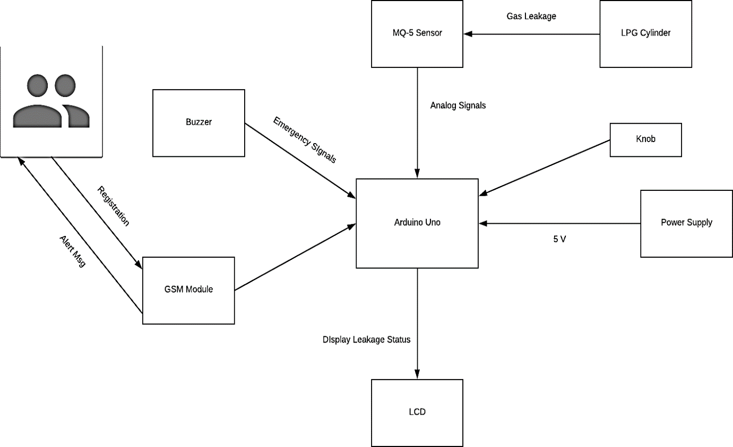
Fig 2.2 Proposed System Architecture

2.4 METHODS AND MATERIAL

System: Input, Output, Function, Success, Failure
Input: Sensor data signal which is not regular or Change in Signal
Output: End User get informed with alert buzzer and Display to LCD
Functions:
Access: - In this module we are going to access the feature provided by the module which Will include Sensor data access.
Control: -In this module we are controlling the Alert System by using System which is connected to hardware or sensor data.
Broadcast: -In this module we are going to broadcast the alert Display to LCD.
Success Conditions: If such data which is received through sensors are not stable or are more than threshold it will predict that there is leakage situation
Failure Conditions: Desired output is not generated due to following failures.
Software Failure, Hardware Failure and Network Connection Failure.

CHAPTER - 3

IDEATION

3.1 EMPATHY MAP
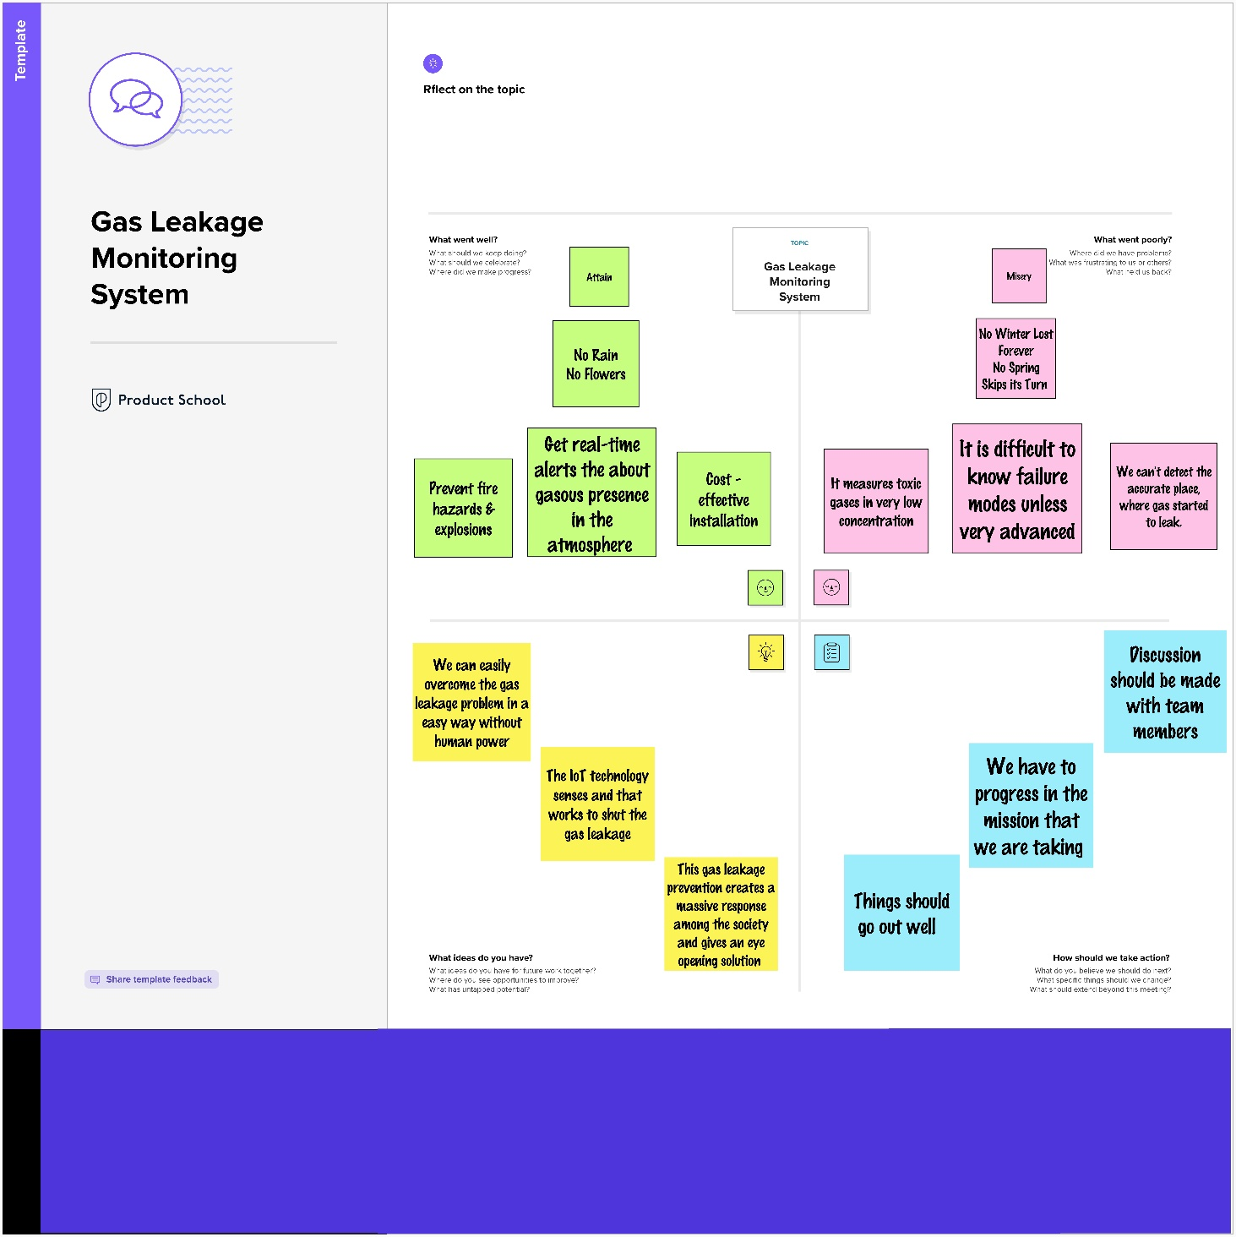
Fig 3.1 Empathy Map

3.2 BRAINSTROMING
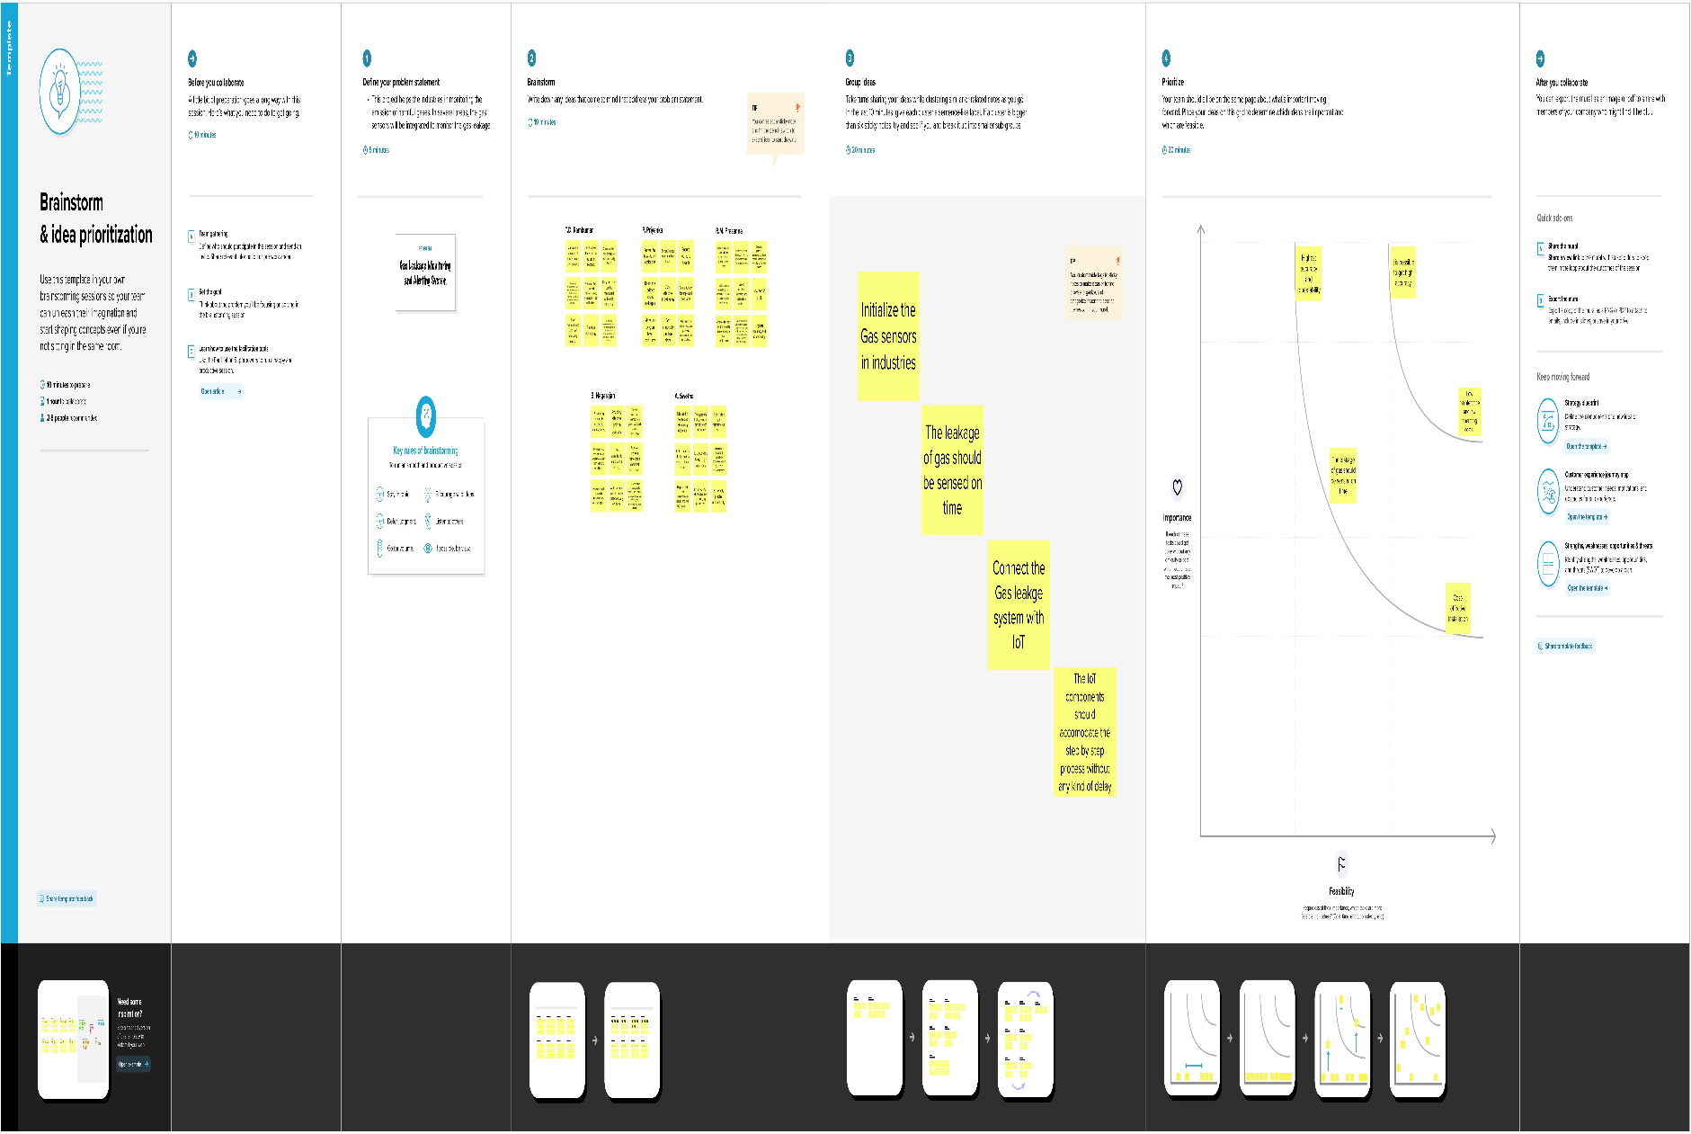
Fig 3.2 Brainstrom

3.3 PROPOSED SOLUTION

S. No. | Parameter | Description
1. | Problem Statement (Problem to be solved) | This project helps the industries identify the gas leakage beforehand to take necessary precautions to stop them.
2. | Idea / Solution description | The operating principle is that the escape of gas from a high-pressure pipeline or other pressurised systems generates ultrasound, which when detected by an acoustic sensor, can provide a measure of the leak rate.
3. | Novelty / Uniqueness | In several areas, the gas sensors will be integrated to monitor the gas leakage. If any area gas leakage is detected the admins will be notified along with the location. In the web application, admins can view the sensor parameters.
4. | Social Impact / Customer Satisfaction | The sensing of toxic gases such as H2S, Methane, and CO is of great importance in any industry to avoid unwanted leakage and consequences like poisoning or explosions.  The presence of these gases can be easily detected in the industrial facilities and commercial buildings with the help of IoT-powered gas monitoring solution.  Moreover, a gas detector or sensor device is a crucial part to carry out safe industrial operations. The sensor-enabled solution helps prevent the high risk of gas explosions and affecting any casualties within and outside the premises.
5. | Business Model (Revenue Model) | Business – To – Business Model (B2B)  Business – To – Customer Model (B2C)
6. | Scalability of the Solution | Most of Gas explosions are caused by undetected gas leakage in the pre-detection condition. So that, Gas leakage monitoring and alerting system is needed. The purpose of this system is to detect gas leakage, neutralize it, and prevent the explosion.

Table 3.1 Proposed Solution

3.4 PROPOSED SOLUTION FIT


Fig 3.3 Proposed Solution Fit

CHAPTER – 4

REQUIREMENT ANALYSIS

4.1 FUNCTIONAL REQUIREMENTS
FR No. | Functional Requirement (Epic) | Sub Requirement (Story / Sub-Task)
FR-1 | Monitoring | Level of gas is monitored using sensor and if there is any leakage, alert can be sent through messages and with a buzzer sound.
FR-2 | User Reception | The data like the level of gas can be send through messages
FR-3 | User Understanding | The user can monitor the level of gas with the help of the data. If  there is an increase in gas level then the alert will be given by message or buzzer sound.
FR-4 | User Performance | When the user gets notified, they could take precaution steps like turning the gas off, turn on the exhaust fan/sprinkler and avoid  serious accidents.

Table 4.1 Functional Requirements
4.2 NON – FUNCTIONAL REQUIREMENTS

FR No. | Non-Functional | Requirement Description
FR-1 | Usability | It updates the data regularly as well as protects the workers.
FR-2 | Security | As a result of emergency alert, we can be able to protect both the humans and properties. Precaution steps could be taken.
FR-3 | Reliability | Can be able to provide accurate values. It might have a capacity to recognize the smoke accurately and does not give a false
FR-4 | Performance | Sprinklers and exhaust fans are used in case of emergency
FR-5 | Availability | It can be used for everyday; it includes day and nights.
FR-6 | Scalability | Sensors can be replaced every time it fails

Table 4.2 Non – Functional Requirements

CHAPTER – 5

PROJECT DESIGN
5.1 DATA FLOW DIAGRAM
5.1.1 ARDUINO UNO
Microcontroller Arduino UNO is employed is shown in fig. The central unit of the system is Arduino board, where all the components are interfaced externally on the board and programmed as per their functionality to work in synchronization. it's an electronic prototyping platform/ board supported Atmega-328 which is of 8-bit, 16 Mhz. during this serial communication is enabled and has 14 digital input /output pins (out of which 6 are PWM) and 6 analog input pins. It operates at 5v. every pin contains a specific function to control. The storage is non-volatile storage and EEPROM. The key comparison of a non-volatile storage with the EEPROM is that the incontrovertible fact that non-volatile storage contents are erasable. In contrast to a EEPROM, the entire device is erased. where one can erase and judge on bases of Byte and section. The availability of the non-volatile memory during which the blocks of the contains are divided and therefore block by block the portion is erased, where an no erased option is provided for the EEPROM byte. thanks to the actual fact that the programming of the non-volatile storage performed while it’s on the system board socket. BIOSROM of the PCB is the new upgrade which is immensely used.
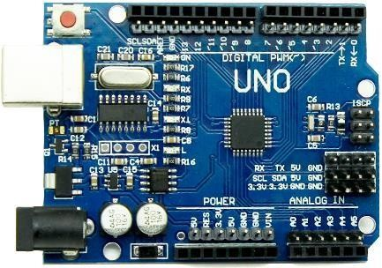

Fig 5.1 Arduino Uno

5.1.2 MQ2 SENSOR

MQ-2 gas sensor module is shown in fig. It is a sensor detector used to detects the flammable gas and smoke concentration of the combustible gas in the air, and output is read in the analog voltage and digital value output. Supply input voltage is 5v. it is very sensitive to H2, LPG, CH4, CO, SMOKE, PROPANE. It has three pins for transmitter, receiver, ground and sensitivity can be adjust by the potentiometer. Detects LPG from 200ppm to 10000ppm.
Fig 5.2 MQ-2 Gas sensor
5.1.3 GSM MODULE
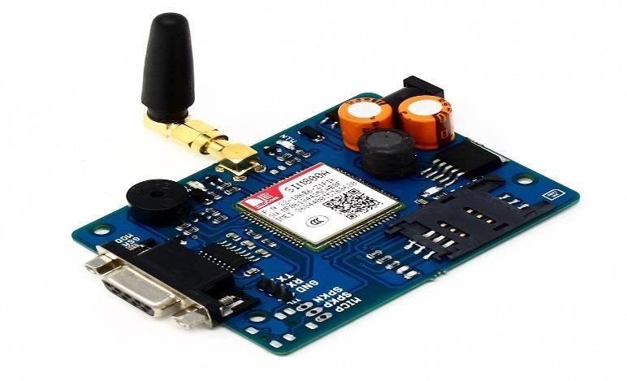
SIM900 GSM module is employed to send SMS alerting on gas detection. GSM is meant as a device used for exchanging the information. SIM card is recovered from the GSM to control the wireless node 5 volts of the DC supply is required by the GSM for functioning. The modem needs only three connections (transmitter, receiver, ground) to interface with Arduino controller Atmega-328 the excess power supply is used. Arduino microcontroller is connected with the receiver pin to the device. The Arduino provide information to the GSM device [2]. The GSM will send an output to through the SIM inserted into its SIM slot to number written into the code to alert about the leakage of the LPG gas or the other gas sensed by the sensor. AT commands are accustomed communicate with GSM module and it's shown in figure.
Fig 5.3 GSM Module
5.1.4 LCD
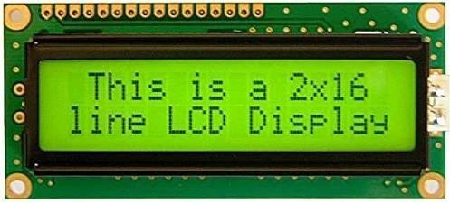
LCD is employed for displaying the message indicating that” gas detected at zone” into the display, which is initially coded in program to display the danger. The message been displayed on the LCD, data and command both are register of LCD and it's shown in fig. The register selects are employed to modify the registers. data register RS=1, whereas for the command register RS=0 is employed.
Fig 5.4 16x2 LCD display
5.1.5 BUZZER
Buzzer is used to alarm the beep sound to indicate and warn the danger to the people working around. The buzzer is the output of the system. The sound of the buzzer is beep-beep, which indicates the danger.
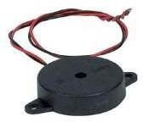

Fig 5.5 Buzzer
5.1.6 LED
LED (Light Emitting Diode) is an optoelectronic device which works on the principle of electro-luminance. Electro-luminance is the property of the material to convert electrical energy into light energy and later it radiates this light energy. In the same way, the semiconductor in LED emits light under the influence of electric field.

5.2 TECHNICAL ARCHITECTURE

Fig 5.6 Technical Architecture

5.2.1 COMPONENTS & TECHNOLOGIES

S. No | Component | Description | Technology
1. | User Interface | Web UI, Node-RED, MIT app | IBM IoT Platform, IBM Node red, IBM Cloud
2. | Application Logic-1 | Create IBM Watson IoT platform and create node-red service | IBM Watson, IBM cloud ant service, IBM node red
3. | Application Logic-2 | Develop python script to publish and subscribe to IBM IoT Platform | Python
4. | Application Logic-3 | Build a web application using node-red service | IBM Node-red
5. | Database | Data Type, Configurations etc | MySQL
6. | Cloud Database | Database Service on Cloud | IBM DB2, IBM Cloud ant etc.
7. | File Storage | Developing mobile application to store and receive the sensors information and to react accordingly | Web UI, python
8. | External API-1 | Using this IBM Gas Leakage management API, we can track the Gas of the incident place and where the Gas had been attacked. | IBM Gas Leakage management API
9. | External API-2 | Using this IBM Sensors it detects the fire,  gas leaks , temperature and provides the activation of sprinklers to web UI | IBM Sensor
10. | Machine Learning Model | Using this we can derive the object recognition model | Object Recognition Model
11. | Infrastructure (Server  / Cloud) | Application Deployment on Local System / Cloud Server  Configuration | IBM cloud ant, IBM IoT Platform
S. No | Characteristics | Description | Technology
1. | Open-Source  Frameworks | MIT app Inventor | MIT License
2. | Security  Implementations | IBM Services | Encryptions, IBM  Controls
3. | Scalable Architecture | sensor-IoT Cloud based architecture | cloud computing and AI
4. | Availability | Mobile, laptop, desktop | MIT app
5. | Performance | Detects the Fire, gas leak, temperature | Sensors

Table 5.1 Components & Technologies

5.2.2 APPLICATION CHARACTERISTICS

Table 5.2 Application Characteristics
5.2.3 SOLUTION ARCHITECTURE

Fig 5.7 Solution Architecture

The proposed system uses an LPG gas sensor to sense LPG gas when LPG gas leakage occurs. We have used an gas sensor module to detect LPG Gas. When LPG gas leakage occurs, it gives a HIGH pulse on its D0 pin and Arduino always reads its DO pin. When the Arduino board gets a HIGH pulse from a gas sensor then it displays a message LCD display and activates buzzer to generate beep sound. When an LPG gas sensor gives a LOW pulse to Arduino board, then the display shows “no gas leakage” message.

5.3 USER STORIES

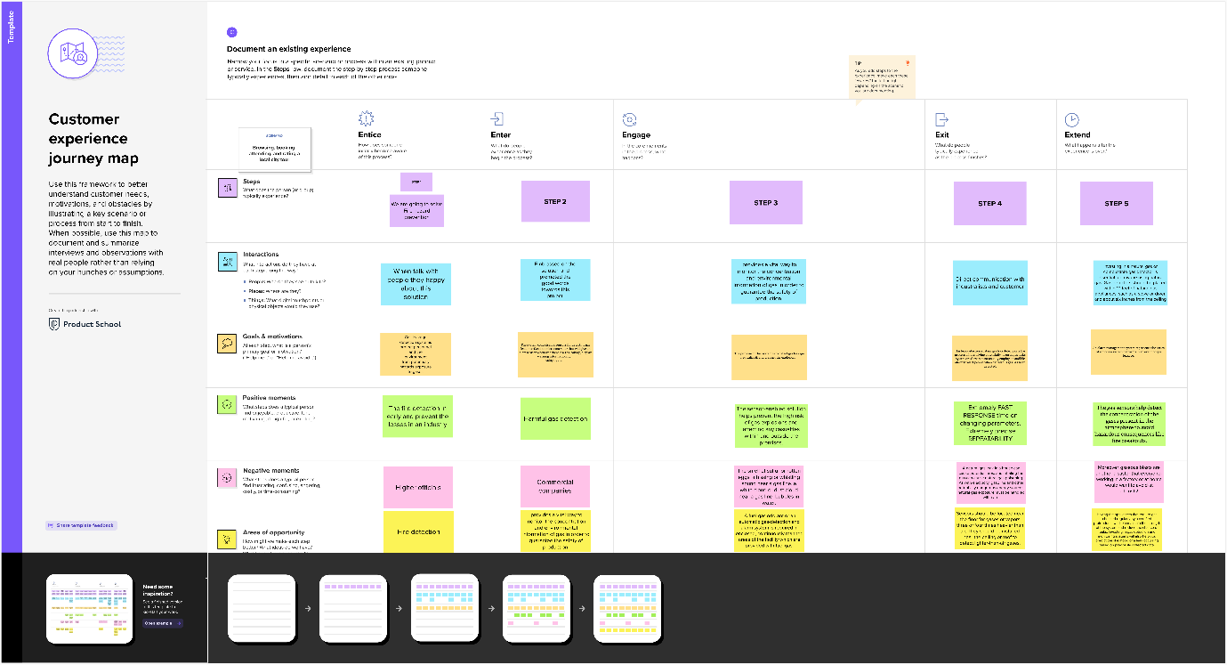
Fig 5.8 Customer Journey Map

` A customer journey is the end-to-end experience a customer has with our brand or business. The reasons for creating a customer journey map include understanding the path and channels of our customers take to get our product. It's a valuable tool that can be used to forecast the path of future customers, as well. Creating a customer journey map can provide insightful information for all levels in a department, from a sales rep who needs to figure out the best ways to interact with potential customers to managers looking for insight on which outlets customers use most. It can also highlight gaps or misdirection and can identify gaps in the customer experience.

CHAPTER - 6

PROJECT PLANNING & SCHEDULING

6.1 SPRINT DELIVERY PLAN

Sprint | Functional Requirement (Epic) | User Story Number | User Story / Task | Story Points | Priority | Team Members
Sprint1 | Monitor the gas leakage | USN-1 | The Industrialist have own industries so the industry owner must take of workers. The workers have family so the industries give security assurance of workers. | 2 | High | T.D. Ramkumar  P. Priyanka  R.M. Prasanna
Sprint2 | Avoid From Disaster | USN-2 | The gas leakage occur at the time fire service will take care to protect the people from the disaster. | 1 | High | A. Swetha  B. Nagarajan  R.M. Prasanna
Sprint 3 | Detect the gas | USN-3 | We have monitored the gas by 24/7 hrs. To avoid leakage, the industry has quality pipes to transfer the gas and proper maintenance service once in a month. | 2 | Low | T.D. Ramkumar  P. Priyanka  A. Swetha  R.M. Prasanna
Sprint4 | The model is trained and tested by sample dataset. | USN-4 | The programmer designs the model to detect the gas leakage. | 2 | Medium | A. Swetha  B. Nagarajan  R.M. Prasanna  T.D. Ramkumar
Sprint5 | Warning message | USN-5 | In case any gas leakage occurs, the device gives the alarm and alert message to concerned user within a minute. | 1 | High | T.D. Ramkumar  R.M. Prasanna  P. Priyanka  A. Swetha

Table 6.1 Sprint Delivery

6.2 MILESTONE & ACTIVITY
Fig 6.1 Milestone & Activity

CHAPTER - 7

7.1 FEATURES

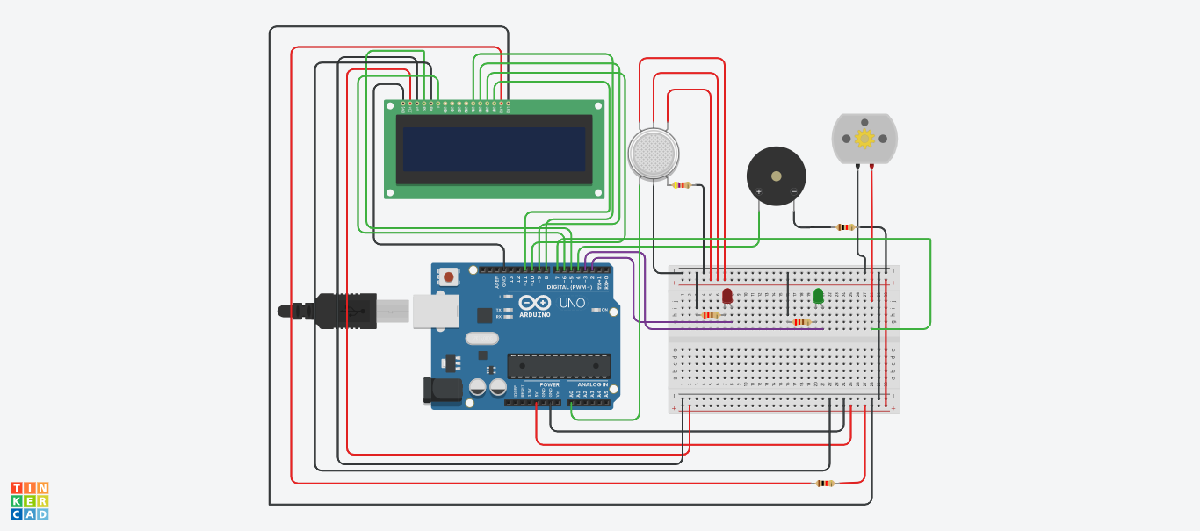
7.1.1 CIRCUIT DIAGRAM
Fig 7.1 Circuit Diagram
Figure 8.1 shows the schematic diagram of our project. This technique has been tested by leak of gas almost about sensors, MQ2 gas sensor sends the signal to the Arduino UNO after detecting the gas leakage. Arduino to other externally connected device such as LCD, buzzer and Motor send vigorous signals. In practice, results for are noticed by the people surrounding by the area are displayed in the LCD and buzzer sound indicate the danger to the people by making beep sound.

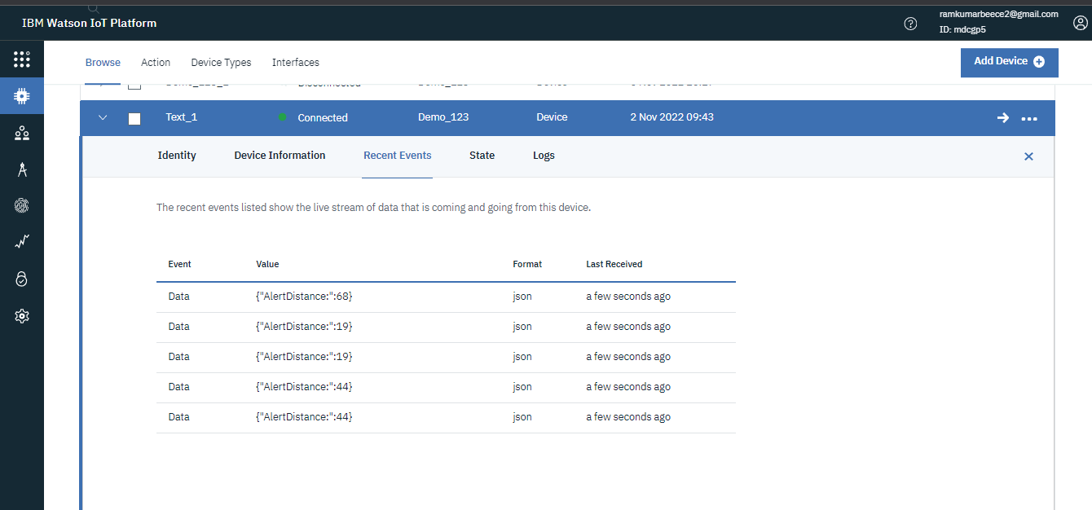
7.1.2 IBM IOT DEVICE

Fig 7.2 IBM IoT Device
The system can be taken as a small attempt in connecting the existing primary gas detection methods to a mobile platform integrated with IoT platforms Such as IBM IoT. The gases are sensed in an area of 1m radius of the rover and the sensor output data are continuously transferred to the local server. The accuracy of sensors is not up to the mark thus stray gases are also detected which creates an amount of error in the outputs of the sensors, especially in case of methane. Further the availability and storage of toxic gases like hydrogen sulphide also creates problems for testing the assembled hardware. As the system operates outside the pipeline, the complication of system maintenance and material selection of the system in case of corrosive gases is reduced. Thus, the system at this stage can only be used as a primary indicator of leakage inside a plant.

7.2 FEATURE 2

7.2.1 CODING

#include <LiquidCrystal.h>
LiquidCrystal lcd(5,6,8,9,10,11);

int redled = 2;
int greenled = 3;
int buzzer = 4;
int sensor = A0;
int sensorThresh = 400;
int fan = 7;

void setup()
{
pinMode(redled, OUTPUT);
pinMode(greenled,OUTPUT);
pinMode(buzzer,OUTPUT);
pinMode(sensor,INPUT);
pinMode(fan,OUTPUT);
Serial.begin(9600);
lcd.begin(16,2);
lcd.setCursor(0,0);
lcd.print("Welcome To Gas");
lcd.setCursor(0,2);
lcd.print("Leakage Monitor");
delay(1000);
lcd.clear();
}
void loop()
{
int analogValue = analogRead(sensor);
Serial.print(analogValue);
if(analogValue>sensorThresh)
{
digitalWrite(redled,HIGH);
digitalWrite(greenled,LOW);
digitalWrite(fan,HIGH);
tone(buzzer,1000,10000);
lcd.clear();
lcd.setCursor(0,1);
lcd.print("ALERT");
delay(1000);
lcd.clear();
lcd.setCursor(0,1);
lcd.print("EVACUATE:");
lcd.print("FAN ON");
delay(1000);
}
else
{
digitalWrite(greenled,HIGH);
digitalWrite(redled,LOW);
digitalWrite(fan,LOW);
noTone(buzzer);
lcd.clear();
lcd.setCursor(0,0);
lcd.print("SAFE");
delay(1000);
lcd.clear();
lcd.setCursor(0,1);
lcd.print("ALL CLEAR");
delay(1000);
}

}

CHAPTER - 8
8.1 TESET CASES
We design and develop an propose system which include some safety factors. A safety has been a major issue in today’s day to day life. LPG and CNG i.e. petroleum gas and compressed natural gas are most commonly used in residential and commercial places for cooking purpose and in various vehicles as a replacement for costly fuels like diesel, petrol. These gases are filled in cylinders which are easily un-damageable. But leakage can take place through pipes or regulators or knobs which may cause accidents like suffocation, uneasiness or sometimes may catch fire and short circuit as well. The main aim of this project is developing a system that can detect gas leakage. On detection it will send an alert SMS and the gas supply knob of cylinder will be switched off automatically.


8.1.1 COMPONENT LISTS

Fig 8.1 Components List

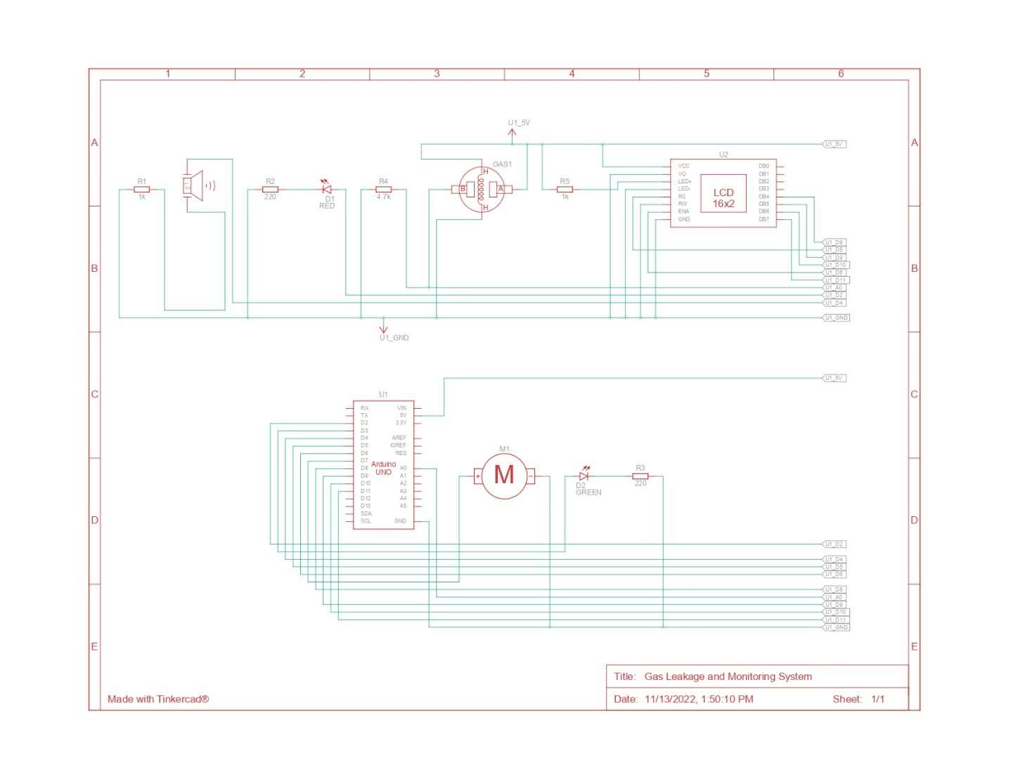
8.1.2 SCHEMATIC VIEW
Fig 8.2 Schematic View
IBM IOT Watson is an IoT analytics platform service that allows to aggregate visualize and analyse live information streams in the cloud. IBM Cloud provides instant visualization of information posted by your devices to IBM Watson with the ability to execute PYTHON code in IBM Watson you can perform online analysis and processing of the information as it comes in IBM Cloud is often used for prototyping and proof of concept IoT systems that need analytics.

8.2 MOBILE APP RECOGNITION
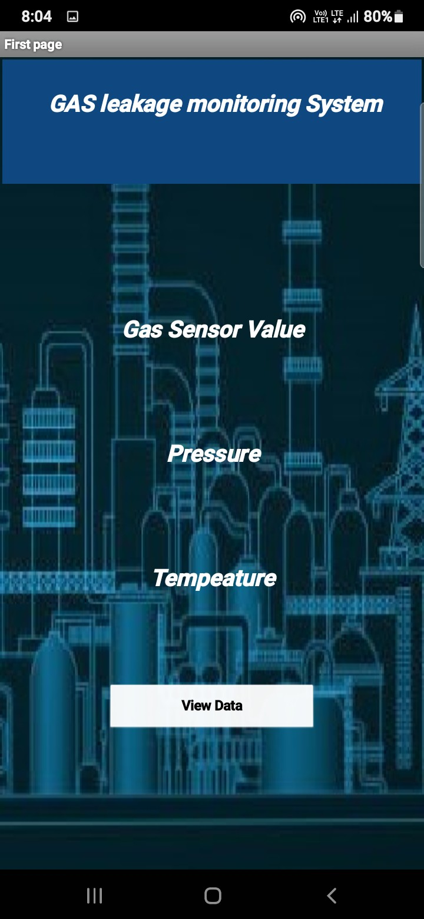
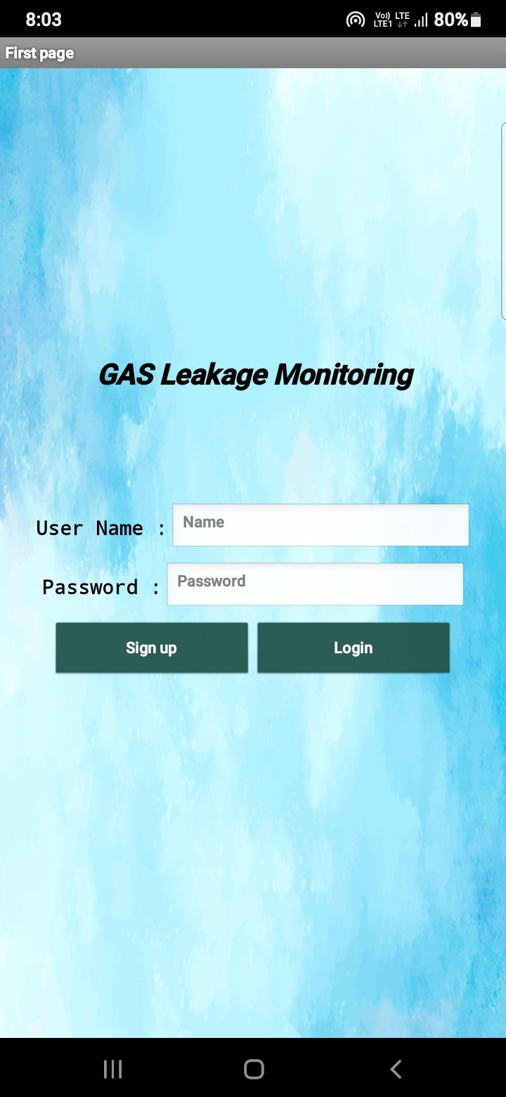

Fig 8.3 App Interface

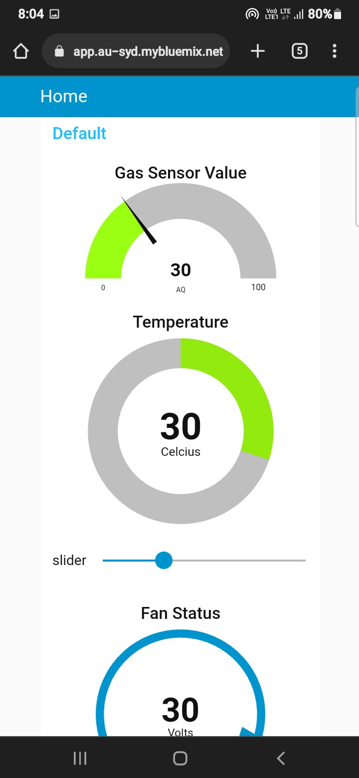
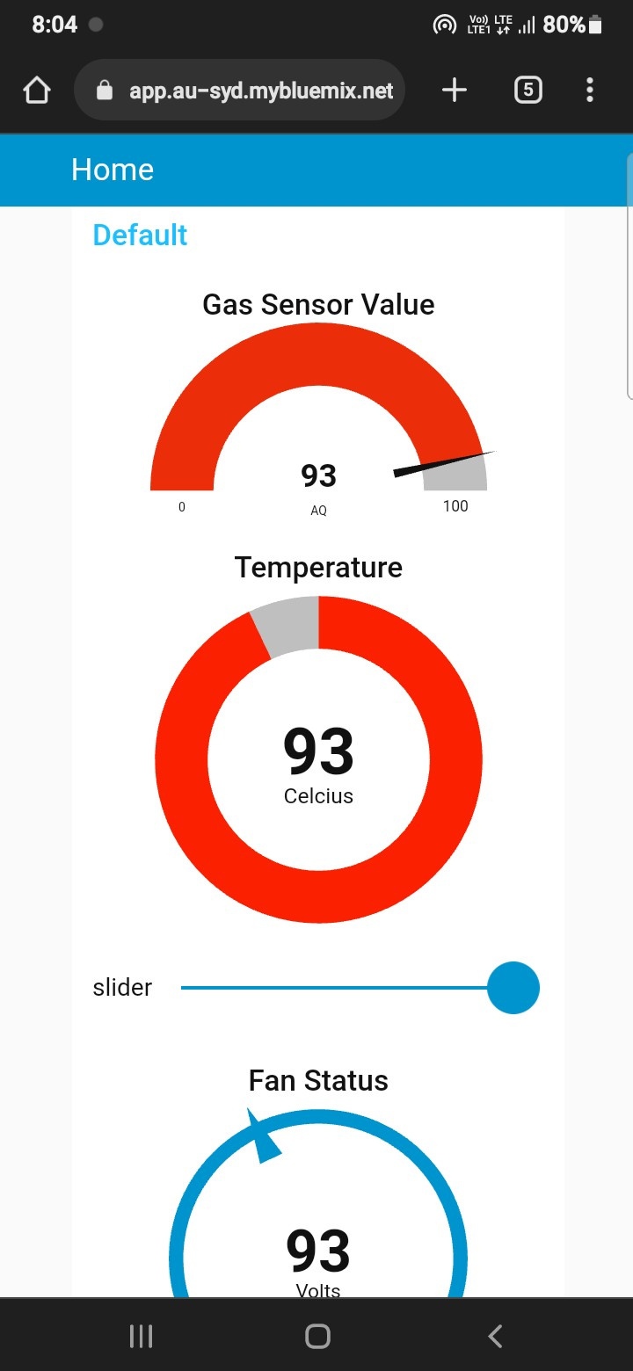
Fig 8.4 Sensors Value

The advantage of this simple gas leak detector is its simplicity and its ability to warn about the leakage of the LPG gas. This system uses GSM technique to send alert massage to respective person if no one is there in the industry and then gas leaks occurs, GSM module is there to send immediate messages to the respective person regarding the gas leak. The main advantage of this system is that it off the regulator knob of the cylinder automatically when gas leakage detected.

CHAPTER - 9
9.1 PERFORMANCE METRICS

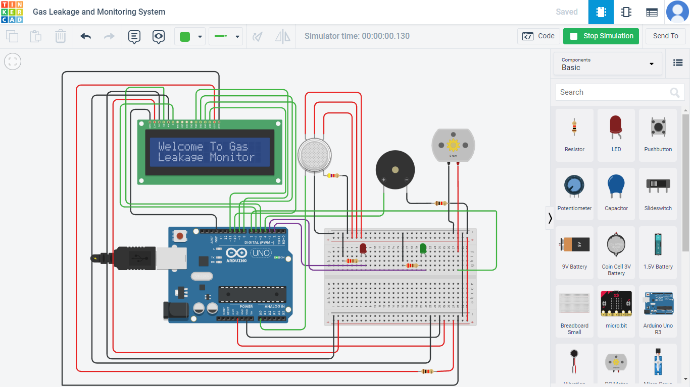
Fig 9.1 Display Result
Monitoring and detection system are planned and when a small leakage occurs, the system sensors detect the leakage and the sends the alert message to the user and activates the alarm. On the other hand, the system monitors the amount of leakage occurred.
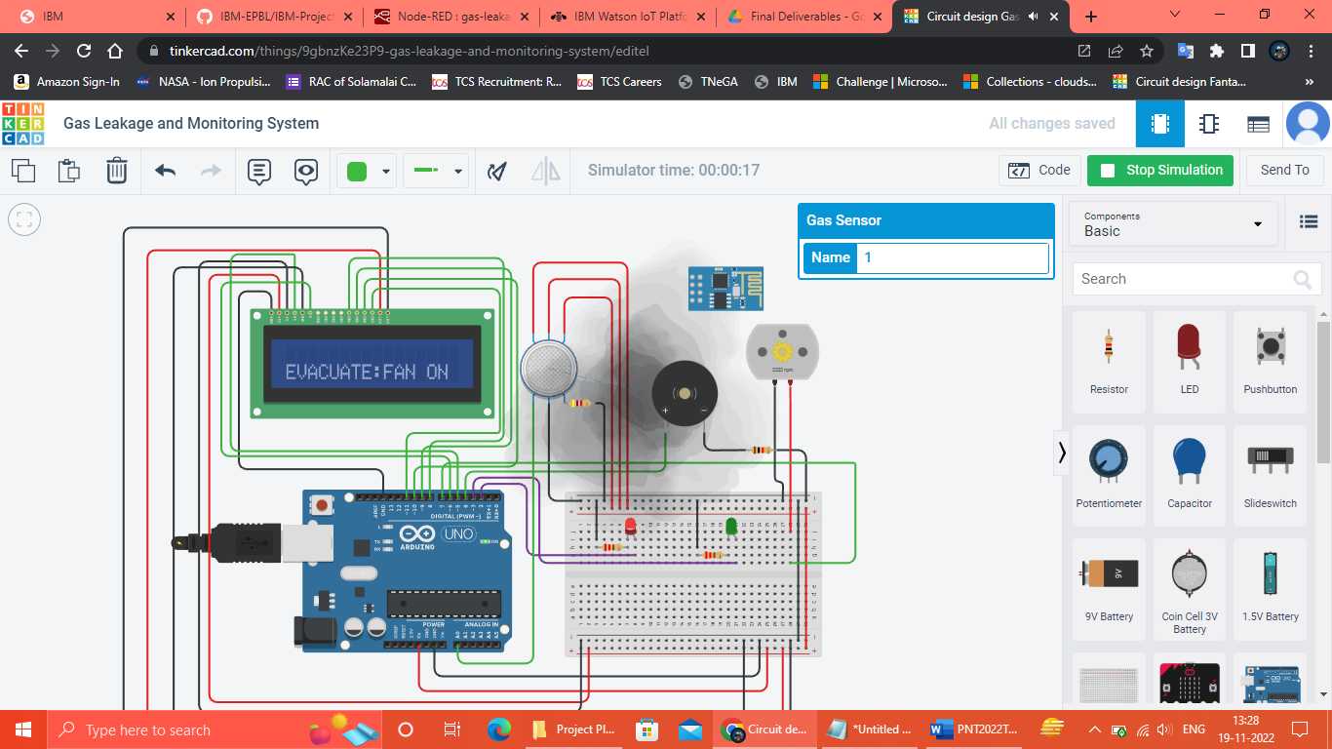
Fig 9.2 SMS To Inform The Customer

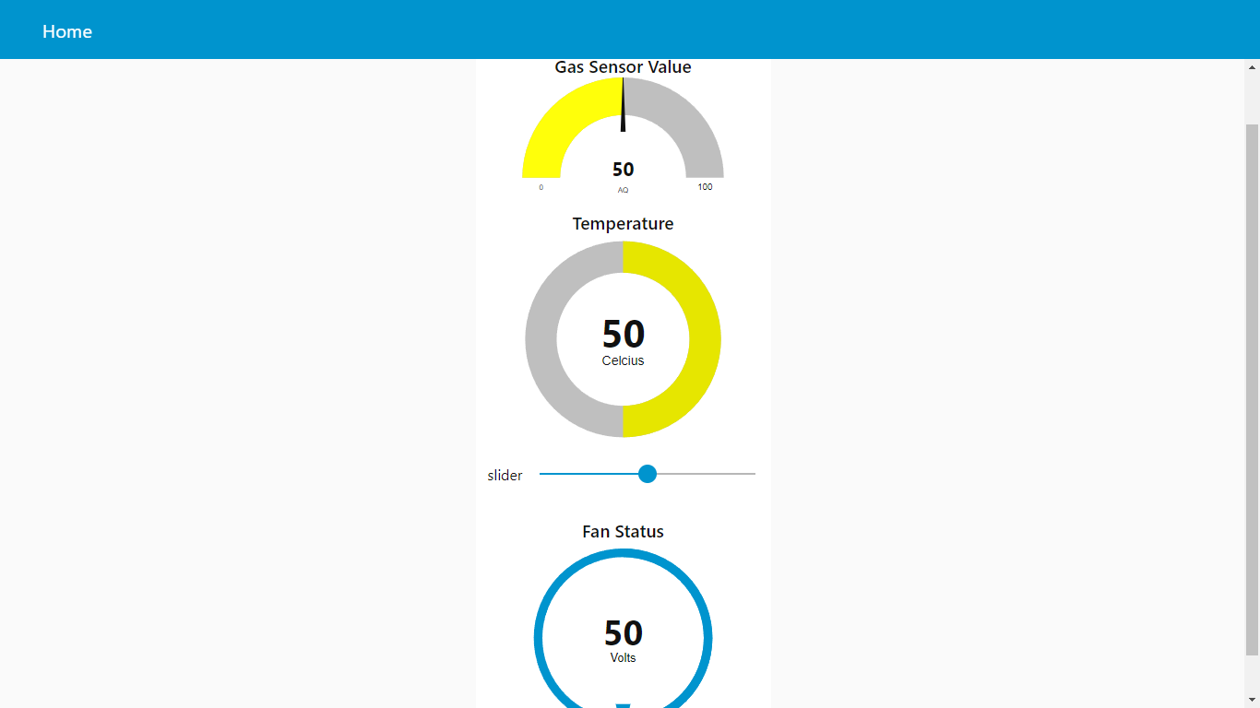
Fig 9.3 Sensors Value

If the gas leakage is sensed more than the Threshold, the warning alarm will be generated by the buzzer and also the GSM modem gets command message, “Alert Gas Leaking” from the microcontroller, it will send the message to the mobile number which is already stored in the microcontroller. This alarms the user that there is gas leakage in the particular area. Alternatively, the main power supply is turned off by the relay and the exhaust fan is turned on to prevent further leakage.

CHAPTER - 10
10.1 ADVANTAGES

- Get real-time alerts about the gaseous presence in the atmosphere
- Prevent fire hazards and explosions
- Supervise gas concentration levels
- Ensure worker’s health
- Real-time updates about leakages
- Cost-effective installation
- Data analytics for improved decisions
- Measure oxygen level accuracy
- Get immediate gas leak alerts

10.1 DISADVANTAGES

- No prevention of fires possible with kit.
- Applicable only as an indicator/alarming device.
- It works only when at 5V power supply is given.
- Its sensitivity depends on Humidity and temperature.
- It is a little sensitive to smoke.

CHAPTER 11

CONCLUSION

In the nutshell, gases are essential in our surrounding due to today’s developments. Gases are everywhere. Gases helps human and gases also can harm human if not handle properly. From this project the hope is very high to make it successful because this innovation can bring benefits to human life. This project enables collection of the data about the gas leakage and analyses it and prevent the leakage occurred.
The estimated source location of gas leakage can be determined by analysing the gas leakage level reading detected on different gas sensor position. Besides, by merging IoT system, the gas leakage can be easily analysed anywhere in the world. At the end of this project, the user can easily monitor the safety of the house or industry in case of gas leakage even from far place. After this project performance, can conclude that detection of the LPG gas leakage is incredible in the project system.
Applicable usefully in the industrial and domestic purpose. In danger situations we are able to save the life by using this system. An alert is indicated by the GSM module. A sensor node senses gas like CO2, oxygen, propane. The estimated range of transmission and consumption of power is obtained. The simple procedures and Arduino UNO Micro controller area used to build the sensor. Its ability to warn its stakeholders about the leakage of the LPG gas.
The future aspects of this detector include the GSM module and a tripper circuit which increases the efficiency of the system and provides more safety to the users. This detector is implemented successfully and is easy to use and also a low-cost product. Another advantage of this device is that even though if no one is there in the house and then gas leaks occurs, GSM module is there to send immediate messages to the stakeholders regarding the gas leak and thus it lowers the intensity of accidents. GSM module in this device ensures better safety regarding the gas leaks.

CHAPTER – 12

FUTURE SCOPE
The Internet of Things is an advanced technology that works on multiple levels creating a smart network of sensor devices, equipment, and assets. These devices help provide valuable data for analysis and allow the industrialists to make better decisions. In a gas monitoring system, the gas detection sensors are installed strategically on different locations for real-time monitoring. These sensors then alert the managers via a centralized platform through live notifications when the gas is detected.
Huge industries, especially oil refineries are severely exposed to harmful explosions and human risks even with a slightest of the gas leak. Moreover, the expenses due to gas leakages are enormous. This ranges from the production loss in food industries to the infrastructure losses by flammable gas leaks including the healthcare costs to treat the patients injured by gas poisoning. In the USA alone, the treatment costs linked to carbon monoxide intoxication is over $1.3 billion and the death losses due to this are over 2000 per year. Hence, advanced level gas sensors or gas monitoring systems help the manufacturers to procure accurate and real-time information regarding accidental gas leaks.
The latest versions of gas sensors are powered with IoT concepts to create live alerts in case of a gas leak or toxic atmosphere. The Internet of Things further helps the industrialists to make better decisions and analyse the situations for enhanced productivity and less infrastructure damage due to gaseous explosions.
A gas monitoring solution not only detects toxic gases but also identifies changes in air quality. It can also be used commercially in in-house buildings to detect the presence of carbon dioxide and other combustible gases. An IoT-enabled gas monitoring system is designed specially to prevent explosions and fire disasters in the facilities and thus save human lives.

CHAPTER – 13

REFERENCE

- Mr. Sameer Jagtap, Prajkta Bhosale, Priyanka Zanzane, Jyoti Ghogare, “LPG Gas Weight and Leakage Detection System Using IoT”, International Journal for Research in Applied Science & Engineering Technology”, Volume 4, Issue 3, March 2016, Pg – 716 to 720.

- Arun Raj, Athira Viswanathan, Athul T S, “LPG Gas Monitoring System”, International Journal of Innovative Technology and Research, Volume 3, Issue 2, February 2015, Pg – 1957 to 1960.

- S Shyamaladevi, V. G. Rajaramya, P. Rajasekar, P. Sebastin Ashok, “ARM7 based automated high-performance system for lpg refill booking & leakage detection”, Journal of VLSI Design and Signal Processing”, Volume 3, Issue 2, 2014.

- S. Sharma, V. N. Mishra, R. Dwivedi, R. Das, “Classification of gases/odours using Dynamic Response of Thick Film Gas Sensor Array”, IEEE Conference on Sensors Journal, 2013.

- Rajeev B. Ahuja, Jayant K. Dash, Prabhat Shrivastava, “A comparative analysis of liquefied petroleum gas (LPG) and kerosene related burns”, Burns, Volume 37, Issue 8, December 2011, Pg – 1403 to 1410.

- Prof. Pankaj C. Warule, Shivam Upadhyay, Snehal S. Shelke, Sumitra K. Khandade, “LPG Detection, Metering and Control System Using Microcontroller”, IJARIIE, Volume 2, Issue 2, 2016, Pg – 648 to 652.

- Ankit Sood, Babalu Sonkar, Atul Ranjan, Mr. Ameer Faisal, “Microcontroller Based LPG Gas Leakage Detector Using GSM Module”, International Journal of Electrical and Electronics Research, Volume 3, Issue2, April- June 2015, Pg – 264 to 269.

- Ashish Shrivastava, Ratnesh Prabhakar, Rajeev Kumar, Rahul Verma, “GSM Based Gas Leakage Detection System”, International Journal of Technical Research and Applications”, Volume 1, Issue2, May- June 2013, Pg – 42 to 45.

- Shivalingesh B. M, Ramesh C, Mahesh S. R, Pooja R, Preethi K. Mane, Kumuda S, “LPG Detection, Measurement and Booking System”, IJRSI, Volume 1, Issue 4, November 2014, Pg – 7 to 10.

- M. Abdulrahim, C. K. Aarthi, “LPG Leakage Monitoring and Multilevel Alerting System”, International Journal of Engineering Sciences & Research Technology, Volume 2, Issue 11, November 2013, Pg – 3287 to 3290.

CHAPTER - 14
APPENDIX SOURCE CODE

PROJECT SIMULATION LINK:
https://www.tinkercad.com/things/9gbnzKe23P9-gas-leakage-and-monitoring-system/editel

GITHUB LINK:
https://github.com/IBM-EPBL/IBM-Project-36559-1660296015

